

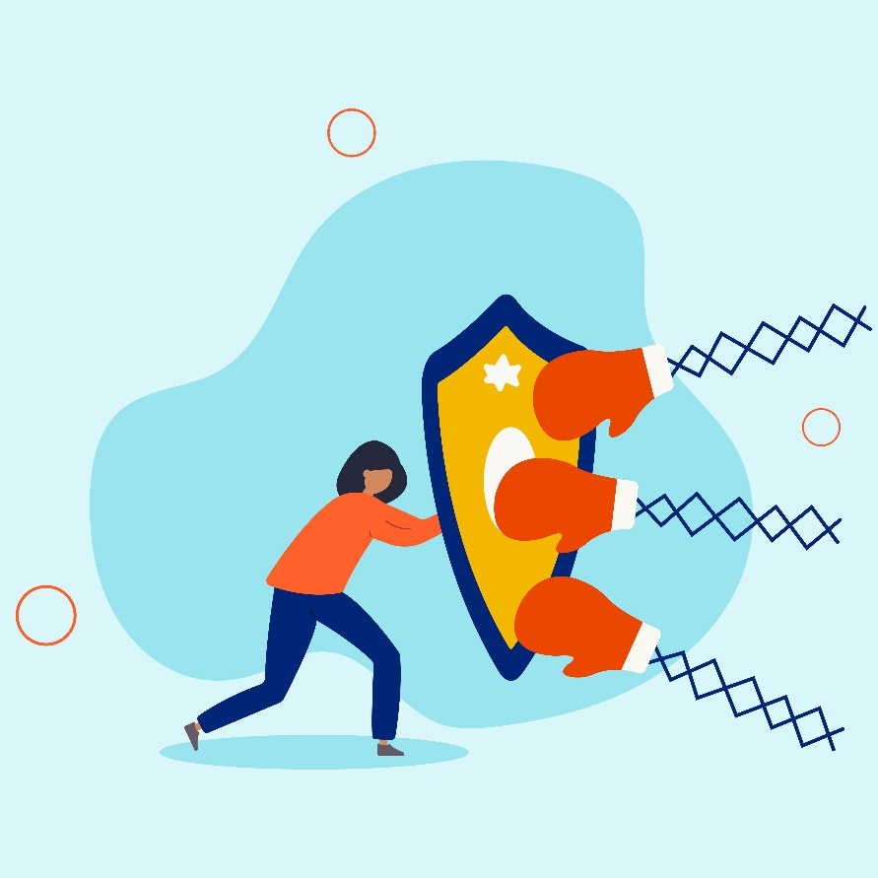

Building Resilience in Traumatic Times

Table of Contents

**The program** 2

**Understanding trauma** 2

Types of trauma 3

Common symptoms of trauma 3

Treating trauma 4

When to seek help 5

**Trauma-Informed Care (TIC)** 5

What is Trauma-Informed Care (TIC)? 5

Principles of Trauma-Informed Care (TIC) 6

The benefits of Trauma-Informed Care (TIC) 6

**Supporting others through trauma** 7

Ways to help 7

Being supportive in the workplace 7

**Building resilience** 8

Understanding resilience 8

Building blocks of resilience 9

Resilience building tactics 9

Self-care strategies 10

**Emotional Wellbeing Solutions (EWS)** 11

**About professional support** 11

**Let’s reflect** 12

**References** 12

### **The program**

Traumatic events can have a significant impact on our emotional and physical wellbeing. It is essential for us to know how to navigate these events to support ourselves and others. This training will explore what trauma is and how it can affect individuals. You will learn how to recognize the signs and symptoms of trauma and identify different coping strategies for overcoming traumatic events. The training will also cover trauma-informed responses and how to create a safe and supportive environment for those in both your professional and personal lives.

The following key topics related to resilience to trauma will be covered:

**Identify** the different types of trauma that people may experience

**Examine** ways that people can support themselves and individuals in their lives who have experienced trauma and learn coping strategies

**Learn** the principles of Trauma-Informed care (TIC) and their benefits

**Define** resilience and identify actions a person can take to build it



### **Understanding trauma**

Trauma is an emotional response that occurs when we experience stressful, frightening, or distressing events that are out of our control or are difficult to cope with.1

**“Trauma is a fact of life. It does not, however, have to be a life sentence.”**

*-Peter A. Levine – Waking the Tiger1*



It has no boundaries as to age, culture, ethnicity, or gender, but how each person manages trauma can vary widely. Trauma can range from something that happened to just you to something your entire community has experienced.

Experiencing a traumatic event can harm a person’s sense of safety, sense of self, and ability to regulate emotions and navigate relationships.2

### Types of trauma

Nearly everyone will experience some form of trauma during their lifetime. However, there are several types of trauma that people may experience. They include3:

**Acute trauma** occurs as the result of a single event that is highly stressful. It can threaten a person’s emotional or physical security and create an impression.4 The reaction is often short-lived. Examples of acute trauma include an act of violence such as assault, a car accident, death of a relative or close friend, etc.

**Chronic trauma** is a response to ongoing or repeated traumatic experiences.3 Examples of chronic trauma are long-term illness, domestic violence, bullying or exposure to extreme situations such as war or unrest.

**Complex trauma** results from exposure to multiple, varied traumatic experiences where there is little to no chance of escape.3 Victims of complex trauma are most likely to suffer from post-traumatic stress disorder (PTSD), though it can result from all types of trauma.4 It is seen most often in victims of childhood abuse or those who have witnessed repeated violence.

**Secondary trauma** occurs when a person has been exposed to other people’s trauma or is closely connected to someone who has experienced trauma, but the event does not happen to them directly.5 It occurs in professions of people who respond to injury or chaotic events such as physicians, first responders, or law enforcement.

**Adverse childhood experiences (ACEs)** are potentially traumatic events that occur during childhood (0-17 years of age) and can undermine a child’s sense of safety and stability.6 ACEs can disrupt the normal course of development and last into adulthood. There are many types of ACEs including food instability, discrimination, homelessness, or abuse.

**Click here to add your notes about the types of trauma**

### Common symptoms of trauma

Depending on the type of trauma, symptoms can last from a few days to a few months, or even years. The way someone reacts to trauma is different for everyone, but there are common symptoms and signs to watch for.7

|  |  |
| --- | --- |
| **Physical symptoms** | **Psychological symptoms** |
| Insomnia | Denial |
| Fatigue | Confusion or difficulty concentrating |
| Racing heartbeat | Anxiety and fear |
| Muscle tension | Anger or mood swings |
| Edginess and agitation | Guilt, shame, or self-blame |
| Aches and pains | Isolation and disconnection |
| Headaches | Flashbacks |
| Upset stomach | Low self-esteem |

**Click here to enter notes regarding symptoms of trauma**

### Treating trauma

Treating trauma can look different for everyone and can also have vastly different outcomes. People are resilient and can heal from traumatic experiences, but not one recovery approach works for every person.8 The goal of treating trauma should be to resolve unpleasant feelings and memories associated with the event.7

One or a variety of the following treatments may be employed by a behavioral and/or physical health professional when helping someone overcome trauma:8 Therapeutic interventions are available in a variety of fashions. The most common include:

**Cognitive behavioral therapy (CBT)**9 – This is an approach that focuses on the relationships between thoughts, feelings, and behaviors with the goal of improving functioning. It is typically conducted in sessions either individually or in a group setting.

**Somatic experiencing** – This therapy is a body-oriented healing approach that focuses on the bodily sensations connected to the traumatic event.7

**Eye Movement Desensitization and Reprocessing (EMDR)** – A therapeutic method that incorporates elements of cognitive-behavioral therapy with eye movements or other forms of rhythmic, left-right stimulation that can “unfreeze” traumatic thoughts with the goal of reducing the emotion and vividness of traumatic memories.7

**Prolonged exposure** – A targeted therapy that exposes a patient to trauma in a safe way, gradually approaching traumatic situations or feelings leading to the patient understanding that the associated traumatic memories are less dangerous.9

Additional treatments include:

* Pharmaceutical interventions – these are often prescribed in conjunction with therapeutic approaches and under supervision of a qualified health professional.8
* Complementary or alternative approaches which could be things like yoga, meditation, deep breathing exercises, or acupuncture

*\*These approaches should be conducted under the care of a qualified health professional to ensure that they are being directed appropriately.*

### When to seek help

When a person or someone close to them has experienced trauma, it can be difficult to know when to seek professional help. It is important to seek professional help if symptoms do not improve over time or begin to interfere with daily life.

Signs that a person may need to seek help are10:

* + Worrying a lot or feeling anxious, sad, or fearful
  + Having trouble remembering or thinking clearly
  + Having nightmares or difficulty sleeping
  + Having frightening thoughts or flashbacks
  + Becoming isolated from family and friends
  + Hyper arousal - being very jumpy and easily startled

**Click here to enter notes related to treating trauma**

### **Trauma-Informed Care (TIC)**

### What is Trauma-Informed Care (TIC)?

Trauma will impact nearly everyone whether it is through experiencing trauma or supporting others through traumatic events. One way that many healthcare providers have embraced to help their patients is through delivering “Trauma-Informed Care” (TIC).11 The concept of TIC is a framework that acknowledges that trauma has likely occurred in a person’s life and promotes recovery over practices that may lead to re-traumatization.

In its simplest form, TIC shifts from asking a person who is struggling:

**What is wrong with you?**

to

**What happened to you?**

The intention of TIC is not to treat symptoms or issues related to abuse or any other form of trauma, but to provide support services in a way that is accessible and appropriate to those who may have experienced trauma.

### Principles of Trauma-Informed Care (TIC)

Over the past several years, TIC has evolved from being specific to patient care, to a framework that supports healthcare providers and staff, to a set of policies and procedures that can be adapted to support staff in various industries.

When an organization seeks to be trauma informed, there are six guiding principles that have been developed in collaboration with the Centers for Disease Control and Prevention (CDC) and the Substance Abuse and Mental Health Services Administration (SAMHSA) that it is recommended are followed.12

****The principles of an approach to TIC are:

**Safety** – people feel both physical and psychological safety as part of an organization.

**Trustworthiness and transparency** – decisions made with the goal of building trust and showing transparency in how they are made.



**Peer support** – people with shared experiences are integrated into the organization and shown as being an important part of daily operations.

**Collaboration and mutuality** – differences are acknowledged and used to help support the making of decisions.

**Empowerment** – the strengths of individuals are recognized, validated, and encouraged to build resilience and the ability to heal from trauma.

**Cultural, historical, and gender issues** - biases and past trauma are recognized and addressed.

### The benefits of Trauma-Informed Care (TIC)

There are a variety of benefits to an organization or individual being trauma informed.

* **Prevention of re-traumatization** – TIC seeks to address the barriers that affect people suffering from trauma, so they are equipped to overcome them.13
* **Psychological safety** - The principles of a trauma-informed approach encourage psychological safety and peer support which allows for the building of healthy, open relationships which can aid in healing from trauma.11
* **Build healthy relationships** - TIC encourages the building of healthy relationships and fosters the healing value of traditional cultural connections that meet the needs of the individual.13
* **Recognition of signs and symptoms** - When a person is trauma-informed, they are more likely to recognize signs and symptoms in themselves or others and can assist in making a positive impact.

**Click here to enter notes about Trauma-Informed Care**

### **Supporting others through trauma**

### Ways to help

It is not easy to know how to help someone you know after they have experienced trauma. Feelings of helplessness can be associated with seeing someone you know and care about dealing with trauma. One thing that you can do to help is to understand some simple things that can be supportive.

**“A kind gesture can reach a wound that only compassion can heal.”**

*-Steve Maraboli - Life, the Truth, and Being Free14*



****Ways that you can help to be supportive include14:

**Listening** – Use active listening and listen without judgement. This can help make the person feel comfortable as they are working to heal.

**Support their need for space** – When someone experiences trauma, they may have their guard up. If they ask for space, either physical or emotional, respect that decision by asking for express permission before physically touching or offering what you think may be helpful advice.

**Be present** – Just knowing that they have someone by their side during trauma and recovery can help a person heal.

**Be patient** – After trauma, a person may need time to process or learn what they need. Avoid assuming you know what they need and do not be afraid to ask but know they may not have an answer right away.

**Offer to help with routine tasks** – Sometimes offering to do tasks such as meal preparation, shopping, or cleaning can go a long way to helping someone heal, especially if they are having difficulty concentrating on what may be considered simple.

### Being supportive in the workplace

Trauma can happen in all aspects of life, including the workplace. The COVID pandemic brought that to the forefront for many employees, especially frontline workers such as those in the healthcare industry.

The effects of trauma, no matter where the trauma occurs, can have a detrimental impact in the workplace such as reduction in productivity or increased absenteeism.15

Ways to support employees who have experienced trauma involve:

* **Removing the stigma** – Encourage open discussion free of judgement. This will help to create psychological safety both for the person or persons who experienced trauma and for the rest of the team whether they are managers or contributors.
* **Offering trauma training** – Not only will training help staff to be informed, but it can also provide support resources and tools for staff to understand their own trauma.
  + **Offering resources to staff who have experienced trauma** – This can be in the form of referrals to appropriate healthcare professionals or a stipend for mental health services to ease possible financial burdens.
  + **Prioritizing the health and wellbeing of all employees** – This often results in a culture where people are in a better position to manage trauma before it happens or know the type of support, they may be able to offer a colleague.

**Click here to enter notes regarding supporting others through trauma**

### **Building resilience**

### Understanding resilience

Dr. Roma Kumar, a Clinical Psychologist in the article *What is Resilience and Why is Resilience Important* defines resilience as “the ability to bounce back from adverse events or challenges”.16 Additionally, Dr. Kumar believes resilience is something you must consciously cultivate even though it is something you naturally acquire through exposure to traumatic events, stressful situations, or trying situations. Being resilient does not absolve you from stress, worry, or emotional turmoil. It means that by modifying ideas and behaviors and resolving your feelings and issues, you can access your inner strength.

According to the Psych Central article *What Resilience Is and Isn’t*, since everyone adjusts and processes trauma differently, resilience is a trait that cannot be chosen. Being resilient does not mean denying, numbing, or ignoring reality. Resilience is distinct from ineffective behaviors like avoidance or unhelpful coping techniques, like misusing alcohol or illegal substances.17

|  |  |
| --- | --- |
| **What resilience is16** | * Ability to bounce back from adverse events or challenges * Naturally and actively built * Tapping into inner strength |
| **What resilience is not17** | * A choice * Numbing, ignoring, or being in denial of something * Separate from avoidance and unhelpful coping mechanisms |



**Click here to enter notes regarding understanding resilience**

### Building blocks of resilience

Resilience can also be actively built. What does it take to build resilience? According to Dr. Kenneth Ginsburg in the article *What is Resilience? How to build resiliency, benefits and more*, there are seven building blocks of resilience that Dr. Ginsburg calls the “7 Cs of resilience”.18

**Competence** is the realization that you possess the ability and know-how to overcome hardship.

**Confidence** is having faith in your own skills and capabilities.

**Connection** is establishing a support system within your community, which gives you a feeling of security.

**Contribution** is having a purpose in life and being aware of your ability to influence people for the better.

**Character** is when you preserve your morals and principles.

**Control** is recognizing that the decisions you make have repercussions and acting accordingly.

**Coping** is the ability to control tense circumstances.

**Click here to enter notes regarding “7 Cs of resilience”**

### Resilience building tactics

Some additional things you can do to build your resilience are:



**Nurture relationships18**



**Make tasks manageable18**



**Practice mindfulness18**



**Find moments of awe18**



**Reframe negative thoughts19**



**Focus on what is within control19**

**Click here to enter note about tactics to build resilience**

### Self-care strategies

In addition to seeking the help of healthcare professionals after a traumatic event, there are things that a person can do to help themselves cope with trauma.

Steps that people can employ to help heal or reduce the possibility of re-traumatization are different for everyone. However, some common strategies are8:



**Eat a healthy diet**



**Avoid self-medicating using alcohol or other substances**



**Exercise \**consult with a healthcare professional before beginning an exercise program.***



**Avoid situations that might be triggers**



**Get plenty of sleep**



**Ask for help**

**Click here to enter note about strategies to build resilience during trauma**

### **Emotional Wellbeing Solutions (EWS)**

* Short term counselling and support for all employees and immediate family members (if eligible).
* Provided at no cost to you by your employer.
* Easily accessible, voluntary, and confidential in accordance with the law – service that can provide support for personal or work-related issues.
* Staffed by experienced professionals.

“This program should not be used for emergency or urgent care, call the local emergency services phone number, or go to the nearest emergency room. This program is not a substitute for a doctor’s or professional’s care. Due to the potential for a conflict of interest, legal consultation will not be provided on issues that may involve legal action against Optum or its affiliates, or any entity through which the caller is receiving these services directly (e.g., employer). This program and its components may not be available in all locations or for all group sizes and is subject to change. Coverage exclusions and limitations may apply. The Optum EWS information in this training is only applicable to the eligible members in attendance.”

### **About professional support**

You may consider seeking professional support if you experience any of the following:

* Sleep problems.
* Performance issues at work.
* Relationship difficulties with family or friends.
* Loss of interest in hobbies you normally enjoy.
* Lack of care about normal everyday work tasks.
* Excessive anxiety or worrying more than normal.
* Feeling overwhelmed or sad for more than two weeks.
* A noticeable change in appetite, eating too little or too much.
* Behavior and coping methods have become harmful to yourself   
  or others, whether that is through aggressive behavior or unhealthy habits, such as drinking too much alcohol or taking drugs.
* Thoughts of harm to self and/or others. *

Keep in mind some of these conditions may warrant more urgent professional help.

Your EWS employee assistance program (EAP) is available to all employees and their covered dependents and may include some free counseling sessions per issue, per year. Please check with your employer or your health plan for details.

*\*If you or someone you know have thoughts about suicide or are in crisis, seek help right away. If you or someone you know is in immediate danger, call 911 — or go to the closest emergency room.*

### **Let’s reflect**

Take some time to answer the questions below using the “**Enter text here**” boxes provided to record your answers.

1. What is one thing that you have learned from this program?

**Enter text here**

1. What is one thing that you would like to research more?

**Enter text here**

### **References**

1Mind. (Dec. 2023). What is trauma? Mind.org.uk. <https://www.mind.org.uk/information-support/types-of-mental-health-problems/trauma/about-trauma/>. Accessed 05 Feb. 2024.

2Centre for Addiction and Mental Health. (n.d.). Trauma. CAMH.ca. [https://www.camh.ca/en/health-info/mental-illness-and-addiction-index/trauma#:~:text=Trauma%20is%20the%20lasting%20emotional,regulate%20emotions%20and%20navigate%20relationships](https://www.camh.ca/en/health-info/mental-illness-and-addiction-index/trauma). Accessed 05 Feb. 2024.

3Psychology Today (n.d.). *Trauma.* Psychologytoday.com. [https://www.psychologytoday.com/us/basics/trauma#the-types-of-trauma](https://www.psychologytoday.com/us/basics/trauma). Accessed 05 Feb. 2024.

4Allarakha, S. (08 Feb. 2021). *What are the 3 types of trauma?* MedicineNet. <https://www.medicinenet.com/what_are_the_3_types_of_trauma/article.htm>. Accessed 06 Feb. 2024.

5National Library of Medicine. (08 Oct. 2022). *Coping with Secondary Traumatic Stress.* Ncbi.nlm.nih.gov. <https://www.ncbi.nlm.nih.gov/pmc/articles/PMC9564895/>. Accessed 05 Feb. 2024.

6Centers for Disease Control and Prevention. (29 June 2023). *Fast facts: Preventing adverse childhood experiences, violence prevention, injury*. Centers for Disease Control and Prevention. <https://www.cdc.gov/violenceprevention/aces/fastfact.html>. Accessed 06 Feb. 2024.

7Robinson, L., Smith, M., & Segal, J. (06 June 2023). *Emotional and psychological trauma*. HelpGuide.org. <https://www.helpguide.org/articles/ptsd-trauma/coping-with-emotional-and-psychological-trauma.htm>. Accessed 06 Feb. 2024.

8Rapaport, L., Pugle, M., Revelant, J., Mastroianni, B., Goldman, R., & Vogt, C. (29 Oct. 2022). *What are the best treatments and therapies for PTSD?* EverydayHealth.com. <https://www.everydayhealth.com/ptsd/guide/treatment/>. Accessed 07 Feb. 2024.

9American Psychological Association. (June 2020). *Treatments for PTSD*. American Psychological Association. <https://www.apa.org/ptsd-guideline/treatments>. Accessed 06 Feb. 2024.

10U.S. Department of Health and Human Services. (May 2023). *Coping with traumatic events*. National Institute of Mental Health. [https://www.nimh.nih.gov/health/topics/coping-with-traumatic-events#:~:text=Those%20who%20continue%20to%20experience,to%20interfere%20with%20daily%20life](https://www.nimh.nih.gov/health/topics/coping-with-traumatic-events). Accessed 14 Feb. 2024.

11*What is trauma-informed care?* Trauma-Informed Care Implementation Resource Center. (07 July 2022). <https://www.traumainformedcare.chcs.org/what-is-trauma-informed-care/>. Accessed 13 Feb. 2024.

12Centers for Disease Control and Prevention. (17 Sept. 2020). *Infographic: 6 guiding principles to a trauma-informed approach*. Centers for Disease Control and Prevention. <https://www.cdc.gov/orr/infographics/6_principles_trauma_info.htm>. Accessed 13 Feb. 2024.

13Office for Health Improvement and Disparities. (02 Nov. 2022). *Working definition of trauma-informed practice*. [https://www.gov.uk/government/publications/working-definition-of-trauma-informed-practice/working-definition-of-trauma-informed-practice#:~:text=Trauma%2Dinformed%20practice%20aims%20to,care%20services%20and%20their%20staff](https://www.gov.uk/government/publications/working-definition-of-trauma-informed-practice/working-definition-of-trauma-informed-practice). Accessed 14 Feb. 2024.

14Gooden, M. (28, Jan. 2022). *How to help someone with trauma: What to say and do*. Psych Central. [https://psychcentral.com/health/how-to-help-someone-with-trauma#ways-to-help](https://psychcentral.com/health/how-to-help-someone-with-trauma). Accessed 12 Feb. 2024.

15Wooll, M. (20 Jan. 2023). *Trauma in the workplace: What it is, and 5 ways leadership can help*. BetterUp. <https://www.betterup.com/blog/trauma-in-the-workplace>. Accessed 12 Feb. 2024.

16Sharma, D. (20 Jan. 2022). *What is Resilience & Why is Resilience Important?* NutSpace. <https://nutspace.in/what-is-resilience-why-is-resilience-important/>. Accessed 14 Feb. 2024.

17Rice, A. (06 Jan. 2022). *What resilience is and isn’t*. Psych Central. [https://psychcentral.com/lib/what-is-resilience#what-its-not](https://psychcentral.com/lib/what-is-resilience). Accessed 14 Feb. 2024.

18Duszynski-Goodman, L. (17 Oct. 2023). What is resilience? How to build resiliency, benefits and more. *Forbes Health*. <https://www.forbes.com/health/mind/resilience/>. Accessed 15 Feb. 2024.

19MSEd, K. C. (03 May 2023). How Resilience Helps You Cope with Life's Challenges. *Verywell Mind*. <https://www.verywellmind.com/what-is-resilience-2795059>. Accessed 20 Feb. 2024.