

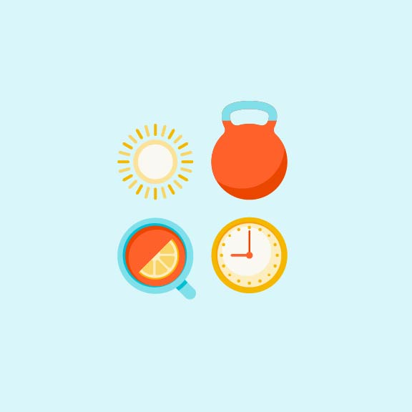

Move to Improve Mental Health

Table of Contents

**The program** 2

**How movement is related to health** 2

What does “movement” mean? 2

Moving data 3

Health benefits of movement 3

**Movement and mental health** 4

What is mental health? 4

Movement related to mental health 5

Benefits to mental health 5

Let’s reflect 6

**Making a move** 6

Start simple 6

What counts? 6

Overcoming barriers 7

Motivating self 8

Motivating others 8

Which activity is best 9

**Emotional Wellbeing Solutions (EWS)** 9

**About professional support** 10

**Let’s reflect** 10

**References** 11

### **The program**

Mental health and physical health are closely connected. Research suggests that increased physical activity of any kind can improve depression, anxiety and ADHD symptoms, improve sleep, and reduce stress. Engaging in regular physical activity has also been shown to reduce the risk of developing depression and other mental health conditions in children and adults. This training program will introduce you to the benefits of movement on mental health. You will learn how movement impacts mental health and learn strategies for adding movement to your daily routine.

The following key topics related to movement and mental health will be covered:

**Learn** the impacts that movement can have on overall health

**Discover** the ways that simple movement and exercises can improve mental health

**Understand** possible obstacles to movement and how to overcome them

**Learn** strategies to begin adding movement to one’s daily routine with the goal of improving mental health



### **How movement is related to health**

### What does “movement” mean?

There are varying definitions of the term “movement.”

**“The act or process of moving, especially a change in place, position, or posture”**

*-Merriam-Webster Dictionary1*



Our bodies are designed to run, jump, and manipulate objects, among other miracles of locomotion.

### Moving data

Regular physical activity is an important thing we can do to improve health or maintain good health.

Physical activity as described by the World Health Organization (WHO), “refers to all movement including during leisure time, transport to and from places, or as part of a person’s work.”2

Physical activity can be done by anyone at any skill level and does not have to be doing specific exercise or going to a gym. Excess sitting is linked with many diseases and conditions, including obesity, hypertension, back pain, cancer, cardiovascular disease, and depression.

According to data from the World Health Organization (WHO):

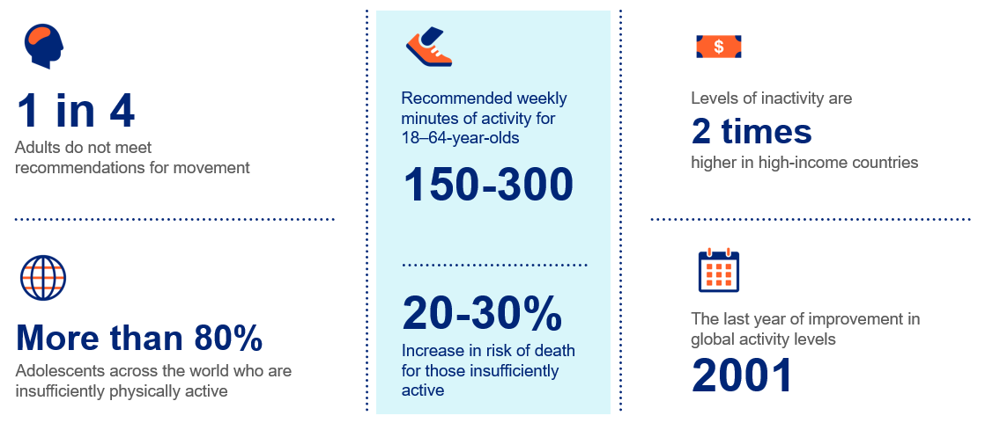

**Click here to add your notes about what movement is.**

*Consult with a health care professional before considering what physical activity/activities you would like to pursue.

### Health benefits of movement

There are both immediate and long-term benefits that can be seen when physical activity is increased.

|  |  |
| --- | --- |
| **Immediate benefits3** | **Long-term benefits** |
| Improved thinking and cognition | Prevention of heart disease, cancer, and type II diabetes2 |
| Reduced short-term feelings of anxiety | Improved mental health2 |
| Improved sleep | Lower risk of stroke4 |
| Weight maintenance | Improved joint mobility4 |
| Prevent falls | Delayed onset of possible cognitive decline4 |

**Click here to enter notes regarding the health benefits of movement**

### **Movement and mental health**

### What is mental health?

Mental health includes emotional, psychological, and social wellbeing.5 It affects how we think, feel and act. Staying in good physical and mental health allows people to:



**Realize their full potential**



**Cope will with the pressures of life**



**Work productively**



**Have positive relationships**



**Make good choices**

Mental health is a continuum, ranging from a state of optimum mental health, to having an illness or disorder which affects thoughts, emotions, or behavior. Most of us are somewhere in the middle of this continuum, most of the time.6

**Click here to enter notes defining mental health**

### Movement related to mental health

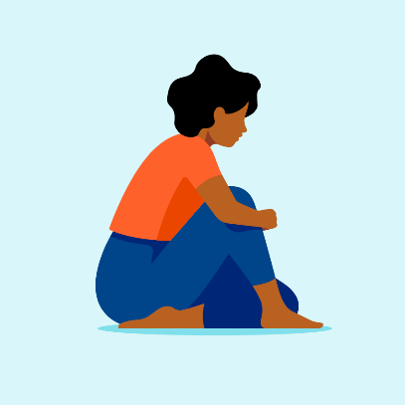Mental health disorders impact more than just the brain. They can have a significant impact on physical health including exacerbating cardiovascular disease and diabetes. Physical health issues such as illness, injury, or disease often impact one’s mental health. It can be hard to stay mentally healthy when your physical health is not well.

There have been many studies conducted and published that have found physical activity can help to treat and prevent a wide range of mental disorders such as depression and anxiety.7

* As little as **10 minutes** of movement can have an immediate impact on one’s mood and outlook.3
* However, the best results were seen in people who adopted physical activity as part of their routine, meeting the WHO recommendations of **150-300 minutes per week**.

When asked, many people who exercise regularly say that they do so because it gives them a greater sense of wellbeing. Physical activity releases chemicals in the brain that make a person feel good. It also has benefits such as boosting self-esteem, improving sleep, and helping concentration.8

### Benefits to mental health

How specifically does movement help improve mental health? Many studies over the past several years have found the following impacts:

* 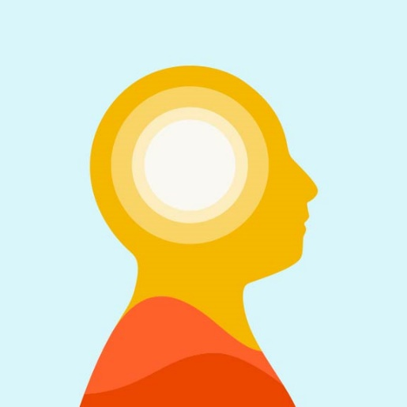**Improved mood** – Research has found that after physical activity, people reported feeling calmer, more awake, and content compared to periods of inactivity.7
* **Decreased stress** – Physical activity can be effective in relieving stress. People who are regularly active tend to have lower rates of stress than those who are less active.4
* **Improved self-esteem** – Self-esteem is how we feel about ourselves and how we perceive our self-worth. It is a key indicator of our mental wellbeing and our ability to cope with life stressors. Physical activity has been shown to positively influence our self-esteem and self-worth.8
* **Reduced dementia and cognitive decline** – The decline in cognitive functions, such as attention and concentration or dementia, can occur in older people. Physical activity has been identified as a protective factor in studies that examined risk factors for dementia. For people who have already developed the disease, physical activity can help to delay further decline in functioning. Physical activity also seems to reduce the likelihood of experiencing cognitive decline in people who do not have dementia.7
* **Reduced depression and anxiety** - Physical activity can be an additional treatment for depression and anxiety. It has few side effects and can be a good complement to attending psychotherapy and counselling.

**Click here to enter notes about the benefits of movement to mental health**

### Let’s reflect

**How has past physical activity impacted your mental health?**

Things to consider:

* What did you do?
* How were you feeling before?
* How were you feeling after?
* Did you repeat the activity?

**Click here to enter your reflections**

### **Making a move**

### Start simple

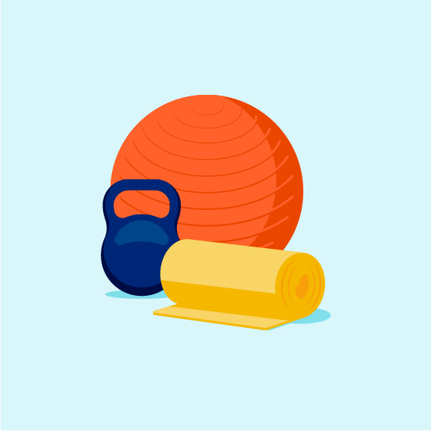A person does not have to strive to be an elite athlete to benefit from movement. The simplest form of activity, like walking briskly to the mailbox or cleaning the house, can help jump start a person’s journey to being active and more mentally healthy.7

The key to start making movement part of your daily routine is to start simply. Think about:

* What do you want to do to be active?
* Do you want to move alone or with another person or group?
* What physical limitations do you have?

*\*Consult with a health care professional before considering what physical activity/activities you would like to pursue.*

**Click here to enter notes about how you would like to start moving**

### What counts?

Often, when people think about movement or physical activity, aerobic exercise or weightlifting come to mind. However, physical activity can be comprised of a variety of things that a person may already be doing or can easily start doing.

Activities that count as movement/physical activity are varied, but include4:

|  |  |
| --- | --- |
| * Gardening | * Stretching while on the phone or at your work desk |
| * Actively playing with children | * A casual bicycle ride |
| * A brisk walk | * Using the stairs |
| * Dancing to your favorite music | * Home improvement projects |
| * Parking the car in the back of the lot |  |

**Click here to enter notes about additional physical activity ideas**

### Overcoming barriers

If moving and being physically active is so easy, why aren’t more people doing it?

It can be a bit scary making changes to your life, and most people get anxious about trying something new. Some common barriers are:

**Lack of energy** – After a long day, or a restless night, the thought of a workout can feel like the last thing you want to do. To overcome it, set time for a quick, five minutes of activity. It will likely make you feel energized and want to do the activity for a longer period of time.9 Alternatively, think of the time of day you tend to have the most energy and see if you can take your break at work during that time to go for a walk, do jumping jacks, etc.

**Feeling overwhelmed** – Similar to lack of energy, feeling stressed or too busy can make it difficult to want to be active. Think of making activity something you want to do and incorporate it into things like playing with your kids or walking while talking on the phone. Starting small will make it easier to add more time into a busy schedule.9

**Body image** – Negative self-image can act as a barrier to participating in physical activity. People who are anxious about how their body will look to others while they are exercising may avoid exercise as a result. Exercising with a companion can help to reduce anxiety about how your body looks to others and may be particularly helpful during the first few exercise sessions.2

**Physical barriers** – Limitations to mobility or injury or illness can make the thought of physical activity seem impossible. People of all abilities can incorporate movement into daily life. Consult a health professional to learn what you can do and listen to your body. Do what you can when you can such as dividing movement into short periods of time, more frequently, for example.9

Keep in mind that making the regular commitment to doing physical activity is an achievement, and every activity session can improve your mood.

**Click here to enter notes about barriers to physical activity**

### Motivating self

Now that you’ve thought about what to do and why, the next thing is to do it. That is easier said than done, so some may need a bit of motivation. Ideas include:

**“Start where you are. Use what you have. Do what you can”**

*-Arthur Ashe, American tennis player*



* **Set goals** – Think about setting a goal for your movement. Strive to make it SMART (Specific, Measurable, Achievable, Relevant, Time-bound) so that when you achieve it, you’ll be motivated to set and achieve the next goal.10
* **Focus on activities you enjoy** – If you don’t enjoy running, then that is not likely to be the best activity. Think about what you like to do and how you feel doing it to keep motivation higher.9
* **Workout when you have the most energy** – Do you bound out of bed in the morning? Consider making that the time to do something active. If you are more energized in the afternoon, schedule time for activity. To stay motivated to move, take advantage of your energy. You’re less likely to skip it if you have energy.9
* **Reward yourself** – Though improved mental health is its own reward, think about other ways to reward yourself for activity. Ideas such as a hot bath, more time watching your favorite television show, or a night out can help to increase motivation.9

### Motivating others

It can be difficult to motivate oneself to be active, but it can also be difficult to motivate someone else. Some strategies to motivate other people to be active include:

* **Make it social** - Consider inviting someone to an exercise class or encourage them to join a social group dedicated to their favorite activity. It builds accountability and camaraderie.10

**“What lies behind you and what lies in front of you, pales in comparison to what lies inside of you.”**

*-Ralph Waldo Emerson, poet*



* **Offer encouragement and praise** – A small amount of activity is better than none, so encouraging someone reluctant to be active may help them get started. Also offer praise when they are active or do well in an activity.10
* **Lead by example** – Before trying to motivate someone else, it is a good idea to be active yourself. You can share what you are doing, how you are successful, and be a moving “advertisement” for the benefits of activity, showing others they have little to lose.11
* **Change the focus** – To some people, “physical activity” can be a negative term. Help them to change the focus by encouraging alternatives to traditional exercise. Things like a charity challenge or hobbies such as photography outdoors can include movement without the label of “exercise.”11

**Click here to enter notes about additional physical activity ideas**

### Which activity is best

According to a blog post on BetterUp.com, “the best physical activity is one you do consistently.”10

Being consistent will help you to build healthy habits and ensure that you will always be able to experience the best of what physical exercise can do. Choose the best activity for you, but if you are struggling with where to start consider9:

* A person doing yoga with a cat

  Description automatically generated**Aerobics** – These are exercises that are designed to increase your heart rate. Examples are running, swimming, and walking.
* **Stretching** – Stretching exercises help to reduce stress and aid in recovery because they have lower impact to muscles and joints. Examples are yoga and tai-chi.
* **Team sports** – Team sports and activities are not only social, they help to build accountability and can also improve skills such as teamwork, communication, and social responsibility.

*\*Consult with a health care professional before considering what physical activity/activities you would like to pursue.*

### **Emotional Wellbeing Solutions (EWS)**

* Short term counselling and support for all employees and immediate family members (if eligible).
* Provided at no cost to you by your employer.
* Easily accessible, voluntary, and confidential in accordance with the law – service that can provide support for personal or work-related issues.
* Staffed by experienced professionals.

“This program should not be used for emergency or urgent care, call the local emergency services phone number, or go to the nearest emergency room. This program is not a substitute for a doctor’s or professional’s care. Due to the potential for a conflict of interest, legal consultation will not be provided on issues that may involve legal action against Optum or its affiliates, or any entity through which the caller is receiving these services directly (e.g., employer). This program and its components may not be available in all locations or for all group sizes and is subject to change. Coverage exclusions and limitations may apply. The Optum EWS information in this training is only applicable to the eligible members in attendance.”

### **About professional support**

You may consider seeking professional support if you experience any of the following:

* Sleep problems.
* Performance issues at work.
* Relationship difficulties with family or friends.
* Loss of interest in hobbies you normally enjoy.
* Lack of care about normal everyday work tasks.
* Excessive anxiety or worrying more than normal.
* Feeling overwhelmed or sad for more than two weeks.
* A noticeable change in appetite, eating too little or too much.
* Behavior and coping methods have become harmful to yourself   
  or others, whether that is through aggressive behavior or unhealthy habits, such as drinking too much alcohol or taking drugs.
* Thoughts of harm to self and/or others. *

Keep in mind some of these conditions may warrant more urgent professional help.

Your EWS employee assistance program (EAP) is available to all employees and their covered dependents and may include some free counseling sessions per issue, per year. Please check with your employer or your health plan for details.

*\*If you or someone you know have thoughts about suicide or are in crisis, seek help right away. If you or someone you know is in immediate danger, call 911 — or go to the closest emergency room.*

### **Let’s reflect**

Take some time to answer the questions below using the “**Enter text here**” boxes provided to record your answers.

1. What is one thing that you have learned from this program?

**Enter text here**

1. What is one thing that you would like to research more?

**Enter text here**

### **References**

1Merriam-Webster. (n.d.). *Movement: definition and meaning*. Merriam-Webster Dictionary. <https://www.merriam-webster.com/dictionary/movement#:~:text=%3A%20the%20act%20or%20process%20of,place%20or%20position%20or%20posture>. Accessed 20 Feb. 2024.

2World Health Organization. (05 Oct. 2022). *Physical activity.* World Health Organization. <https://www.who.int/news-room/fact-sheets/detail/physical-activity>. Accessed 21 Feb. 2024.

3Centers for Disease Control and Prevention. (01 Aug. 2023). *Benefits of Physical Activity*. Centers for Disease Control and Prevention. [https://www.cdc.gov/physicalactivity/basics/pa-health/index.htm. Accessed 21 Feb. 2024](https://www.cdc.gov/physicalactivity/basics/pa-health/index.htm.%20Accessed%2021%20Feb.%202024).

4Centers for Disease Control and Prevention. (13 May 2020). *Physical activity: Why it matters*. Centers for Disease Control and Prevention. <https://www.cdc.gov/physicalactivity/about-physical-activity/why-it-matters.html>. Accessed 21 Feb. 2024.

5World Health Organization: WHO. (2022, June 17). *Mental health*. <https://www.who.int/news-room/fact-sheets/detail/mental-health-strengthening-our-response>. Accessed 04 Oct. 2023.

6 Substance Abuse and Mental Health Services Administration (SAMHSA). (n.d.). *What is Mental Health?* SAMHSA. [https://www.samhsa.gov/mental-health. Accessed 10 Oct. 2023](https://www.samhsa.gov/mental-health.%20Accessed%2010%20Oct.%202023).

7Schuch, Felipe Barreto and Davy Vancampfort. (22 Oct. 2021). *Physical activity, exercise, and mental disorders: it’s time to move on.* National Library of Medicine. <https://www.ncbi.nlm.nih.gov/pmc/articles/PMC8638711/>. Accessed 21 Feb. 2024.

8World Health Organization. (07 Oct. 2022). *Physical activity - great for your body, great for your mind*. World Health Organization. <https://www.who.int/news-room/feature-stories/detail/physical-activity---great-for-your-body--great-for-your-mind>. Accessed 22 Feb. 2024.

9Robinson, L., Segal Ph.D., J, and Smith, M.A., M. (05 Feb. 2024). *The Mental Health Benefits of Exercise.* HelpGuide.org. <https://www.helpguide.org/articles/healthy-living/the-mental-health-benefits-of-exercise.htm>. Accessed 20 Feb. 2024.

10Wooll, Maggie. (15 July 2022). *Exercise and Mental Health: Why physical exercise is good for your mind.* BetterUp. <https://www.betterup.com/blog/exercise-and-mental-health>. Accessed 22 Feb. 2024.

11Energise Me. (n.d.). *Encouraging others to be active.* Energiseme.org. <https://www.energiseme.org/getting-active/friends-and-family-toolkit/encouraging-friends-and-family-to-be-active/>. Accessed 22 Feb. 2024.