

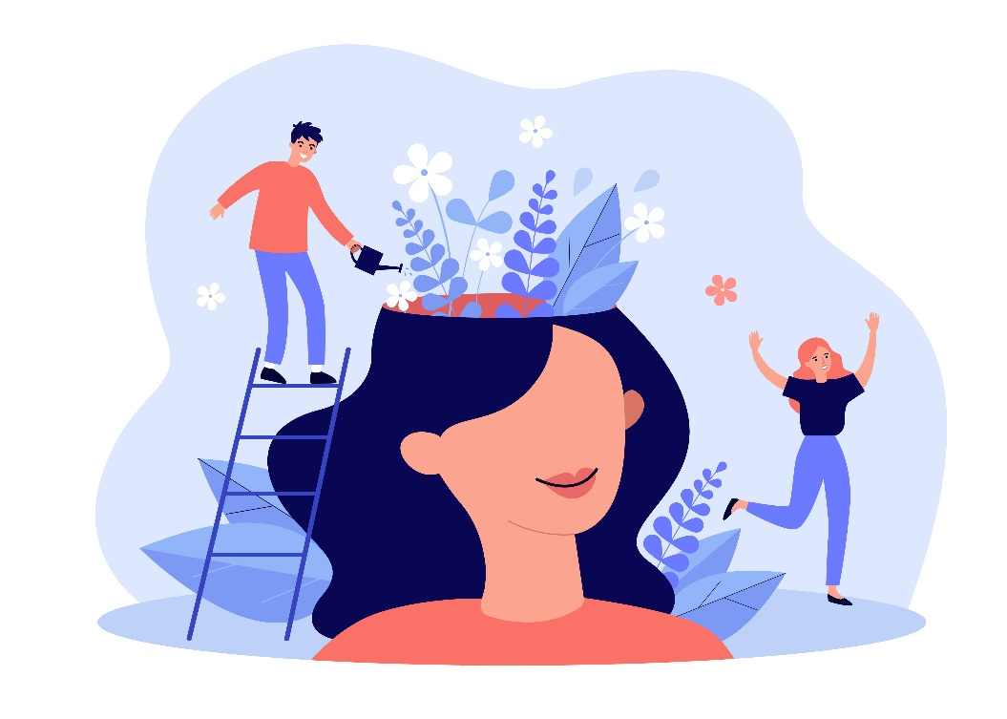

Creating Kindness in the Workplace

Table of Contents

**The program2**

**Giving, kindness and gratitude2**

What is…?**2**

Benefits of giving**3**

Benefits of kindness**4**

The science of gratitude**4**

**Kindness in the workplace5**

Building stronger, healthier relationships in the workplace**5**

Benefits of positive relationships at work**6**

Ways to build positive relationships at work**7**

Being a better listener**8**

Importance of active listening in the workplace**9**

What is workplace kindness**10**

How to promote kindness in the workplace**11**

Strategies for promoting gratitude**12**

Benefits of practicing gratitude**13**

**Emotional Wellbeing Solutions (EWS)14**

**About Professional Support14**

**Let’s reflect15**

**References16**

### **The program**

### **What is Mental Health?The Program**

We will discuss these key topics about creating kindness in the workplace:

**Understand** the role of kindness in building strong relationships and promoting positive mental health.

**Identify** strategies and practical ways to demonstrate kindness daily.

**Explore** the science behind gratitude and practical strategies for incorporating it into daily routines.

### **Giving, kindness and gratitude**

### **What is Mental Health?**

What is…?

Before we begin our journey exploring kindness and gratitude in the workplace, we need to define a few terms.

|  |  |  |
| --- | --- | --- |
|  | Giving1 | **Click here to enter your notes related to giving.** |
|  | Kindness2 | **Click here to enter your notes related to kindness.** |
|  | Gratitude3 | **Click here to enter your notes related to gratitude.** |

Benefits of giving

The benefits of giving are:



**Makes you happy4 and 5**

**Click here to enter your notes about making you happy.**



**Promotes good health4 and 5**

**Click here to enter your notes about promoting good health.**



**Boosts self-esteem5**

**Click here to enter your notes about boosting self-esteem.**

Benefits of kindness

Having a helpful attitude, being giving and thoughtful, and acting without expecting anything in return are all part of the practice of kindness.6 It’s easy, cost-free, and health promoting to show kindness. Practicing kindness is good for both the body and mind.6

|  |  |
| --- | --- |
| **Good for the body** | **Good for the mind** |
|  |  |
| **Click here to enter your notes related to good for the body.** | **Click here to enter your notes related to good for the mind.** |

The science of gratitude

There is evidence from science to suggest a link between “gratitude, mindfulness, and mental health”.9 Psychologists Dr. Robert Emmons and Dr. Michael McCullough observed that individuals who wrote about their gratitude are more upbeat and have a better sense of purpose in life.9 Researchers at the Wharton School at the University of Pennsylvania found that when managers express gratitude to their staff, it inspires them to work even harder.9 Karen Cassiday, past President of the Anxiety and Depression Association of America (ADAA), “confirms that over fifteen thousand studies have proved the power of gratitude in improving mental and physical health” concluding that gratitude can lead to better overall health.9



**Brain built on gratitude10**

**Fulfill his or her potential.**

**Enter your notes about brain built on gratitude.**



**Nourish a grateful body10**

**Fulfill his or her potential.**

**Enter your notes about nourish a grateful body.**



**Thankful to those you love10**

**Fulfill his or her potential.**

**Enter your notes about thankful to those you love.**

### **Kindness in the workplace**

### **StatisticsWhat can lead to Mental Illness?**

Building stronger, healthier relationships in the workplace

People are by nature social. According to Mind Tools, “considering that we spend one-third of our lives at work”11 it is important to have good, strong, and healthy relationships in the workplace. Per Indeed, “relationships in the workplace are the interactions you have with your colleagues.”12 A fulfilling work routine is more likely when you have positive working relationships with coworkers and other professionals. Forming relationships at work helps with networking, provide you with direction, and give you the support you may need to be successful in your position.12 According to Indeed, strong, and healthy work relationships can provide “increased satisfaction with your career, increased comfort with presentations/team meetings, improved productivity for all team members, moral support and assistance with meeting challenging timelines, and higher retention rates.”12



**Trust12**

**Click here to enter your notes about trust.**



**Acceptance12**

**Click here to enter your notes about acceptance.**



**Teamwork12**

**Click here to enter your notes about teamwork.**



**Open communication12**

**Click here to enter your notes about open communication.**

Benefits of positive relationships at work

One of the most crucial aspects of any job is developing positive working relationships. The benefits of developing positive relationships at work are14:

Ways to build positive relationships at work

Developing healthy relationships at work takes time and dedication. But the benefits are substantial, both in terms of the individual and their career.

|  |  |  |
| --- | --- | --- |
|  | Use effective communication13 | **Click here to enter your notes about using effective communication.** |
|  | Build trust13 | **Click here to enter your notes about building trust.** |
|  | Show appreciation13 | **Click here to enter your notes about showing appreciation.** |
|  | Be a team player13 | **Click here to enter your notes about being a team player.** |
|  | Improve conflict resolution13 | **Click here to enter your notes about improving conflict resolution.** |
|  | Have empathy13 | **Click here to enter your notes about having empathy.** |
|  | Practice networking13 | **Click here to enter your notes about practicing networking.** |
|  | Get involved with mentorship13 | **Click here to enter your notes about getting involved with mentorship.** |
|  | Balance personal and professional boundaries13 | **Click here to enter your notes about balancing personal and professional boundaries.** |
|  | Continuous learning13 | **Click here to enter your notes about continuous learning.** |

Being a better listener

According to Vantage Circle HR Blog, “people spend between 70% and 80% of their day engaged in some form of communication, and about 55% of their time is devoted to listening”15, so the way we listen to others plays a crucial role in building stronger relationships at work.

How do you ensure that you are using your best listening skills – you actively listen. When you actively listen, you pay close attention to what is being said and are not just passively taking in what the other person is saying.15 How do you actively listen – let’s review some of the key skills for active listening:

|  |  |  |
| --- | --- | --- |
|  | Attitude15 | **Click here to enter your notes about attitude.** |
|  | Attention15 | **Click here to enter your notes about attention.** |
|  | Adjustment15 | **Click here to enter your notes about adjustment.** |
|  | Face the speaker15 | **Click here to enter your notes about facing the speaker.** |
|  | Use your mind15 | **Click here to enter your notes about using your mind.** |
|  | Don’t interrupt15 | **Click here to enter your notes about not interrupting.** |
|  | Ensure understanding15 | **Click here to enter your notes about ensuring understanding.** |
|  | Be empathetic15 | **Click here to enter your notes about being empathetic.** |
|  | Give regular feedback15 | **Click here to enter your notes about giving regular feedback.** |

Importance of active listening in the workplace

**Trust building** requires you to be a good listener. To have strong and healthy relationships in the workplace it is critical to have trust in your colleagues. According to Vantage Circle HR Blog, to build trust you need to “lend an ear, be honest and supportive, be non-judgmental, and have healthy communication”.15

**Productivity** benefits when colleagues actively listen. When colleagues actively listen to each other’s ideas and views productivity and performance increase.15



Conflicts are going to happen in the workplace whether they are because of differences in perspective, misconceptions, or lack of recognition. To **resolve conflicts** active listening enables you to understand other people’s perspectives and helps you value each other’s differences.15



**Stronger work relationships** and greater empathy are formed by those who actively listen to understand.15



**Self-empowerment** builds confidence. Through active listening you learn what is advantageous to you at work, broaden your viewpoint, communicate better with your colleagues, and empower yourself.15



At the heart of every company is its culture, vision, mission, values, and their **acceptance**. For organizational success everyone needs to be aligned toward a common goal and active listening amongst colleagues helps that goal.15

What is workplace kindness

Kindness in the workplace leads to happier, more engaged, and more productive workers, which gives businesses with compassionate cultures a competitive edge.16 Kindness is a highly valuable attribute for a company’s success. Companies that practice and promote kindness in addition to seeing increased productivity and profitability, have enhanced relationships and a greater degree of trust among colleagues.16

What exactly is workplace kindness? Per Business Leadership Today and put simply “workplace kindness is when you offer a positive attitude and goodwill toward those you work with”.17 Why is workplace kindness so important?

|  |  |  |
| --- | --- | --- |
|  | Job satisfaction17 | **Click here to enter your notes about job satisfaction.** |
|  | Engagement17 | **Click here to enter your notes about engagement.** |
|  | Loyalty17 | **Click here to enter your notes about loyalty.** |
|  | Productivity17 | **Click here to enter your notes about productivity.** |
|  | Positive workplace culture17 | **Click here to enter your notes about positive workplace culture.** |

How to promote kindness in the workplace

Promoting kindness in the workplace is quite simple and can be practiced by everyone in an organization every day with little effort and no cost. How do you promote kindness in the workplace?



**Smile18**

**Click here to enter your notes about smiling.**



**Show gratitude18**

**Click here to enter your notes about showing gratitude.**



**Foster meaningful conversations18**

**Click here to enter your notes about fostering meaningful conversations.**



**Prioritize positivity18**

**Click here to enter your notes about prioritizing positivity.**



**Set the mood18**

**Click here to enter your notes about checking your vibe.**



**Learn everyone’s name18**

**Click here to enter your notes about learning everyone’s name.**

Strategies for incorporating gratitude

You previously explored the scientific evidence that links gratitude, mindfulness, and mental health.You also explored how gratitude goes beyond a fleeting sense of happiness and that stronger relationships can result from practicing gratitude. Let’s look at some strategies for incorporating gratitude.

|  |  |  |
| --- | --- | --- |
|  | Make and maintain a thoughtful journal of gratitude9 | **Click here to enter your notes related to maintaining a journal of gratitude.** |
|  | Write yourself a gratitude list9 | **Click here to enter your notes related to writing a gratitude list.** |
|  | Spread gratitude: write a gratitude note to others9 | **Click here to enter your notes related to writing a gratitude note to others.** |
|  | Practice gratitude-based meditations9 | **Click here to enter your notes related to practicing gratitude-based meditations.** |
|  | Practice gratitude with the bigger picture in mind9 | **Click here to enter your notes related to practicing gratitude with the bigger picture in mind.** |

Benefits of practicing gratitude

By practicing gratitude, you begin to shift your focus from the challenges of life to the good things that often get overlooked. With that shift in focus, you begin to see benefits across all aspects of your life.

|  |  |  |
| --- | --- | --- |
|  | Life benefits19 | **Click here to enter your notes related to life benefits.** |
|  | Social benefits19 | **Click here to enter your notes related to social benefits.** |
|  | Health benefits19 | **Click here to enter your notes related to health benefits.** |

### **Emotional Wellbeing Solutions (EWS)**

* Short term counselling and support for all employees and immediate family members (if eligible).
* Provided at no cost to you by your employer.
* Easily accessible, voluntary, and confidential in accordance with the law – service that can provide support for personal or work-related issues.
* Staffed by experienced professionals.

“This program should not be used for emergency or urgent care, call the local emergency services phone number, or go to the nearest emergency room. This program is not a substitute for a doctor’s or professional’s care. Due to the potential for a conflict of interest, legal consultation will not be provided on issues that may involve legal action against Optum or its affiliates, or any entity through which the caller is receiving these services directly (e.g., employer). This program and its components may not be available in all locations or for all group sizes and is subject to change. Coverage exclusions and limitations may apply.”

### **About professional support**

You may consider seeking professional support if you experience any of the following:

* Sleep problems.
* Performance issues at work.
* Relationship difficulties with family or friends.
* Loss of interest in hobbies you normally enjoy.
* Lack of care about normal everyday work tasks.
* Excessive anxiety or worrying more than normal.
* Feeling overwhelmed or sad for more than two weeks.
* A noticeable change in appetite, eating too little or too much.
* Behavior and coping methods have become harmful to yourself   
  or others, whether that is through aggressive behavior or unhealthy habits, such as drinking too much alcohol or taking drugs.
* Thoughts of harm to self and/or others.

Keep in mind some of these conditions may warrant more urgent professional help and you should seek support if you are unsure.

Your Employee Assistance Program (EAP) is available to all employees and their covered dependents and may include some free counseling sessions per issue, per year. Please check with your employer or your health plan for details.

### **Let’s reflect**

Take some time to answer the questions below using the “**Enter text here**” boxes provided to record your answers.

1. What is one thing that you have learned from this session?

**Enter text here.**

1. What is one thing that you would like to research more?

**Enter text here.**

1. What is one thing that you will do to help build a culture of kindness in your workplace?

**Enter text here.**

### **References**

1Simon, A. (30 August 2023). What does giving mean to you? Explore the true value. *houseoftheharvest.org*. <https://houseoftheharvest.org/giving/what-does-giving-mean-to-you/>. Accessed 3 Jan. 2024.

2*What is kindness? | Kindness is everything*. (4 April 2022). Kindness Is Everything. <https://www.kindnessiseverything.com/faqs/what-is-kindness/>. Accessed 3 Jan. 2024.

3MSEd, K. C. (29 October 2021). *What is gratitude?* Verywell Mind. <https://www.verywellmind.com/what-is-gratitude-5206817>. Accessed 3 Jan. 2024.

4Clinic, C. (27 November 2023). *Why giving is good for your health*. Cleveland Clinic. <https://health.clevelandclinic.org/why-giving-is-good-for-your-health>. Accessed 3 Jan. 2024.

5Hitching, R. (7 December 2020). *4 Benefits of giving to others for a happier life*. HUM Nutrition Blog. <https://www.humnutrition.com/blog/benefits-of-giving/>. Accessed 3 Jan. 2024.

6LPC, S. S. P. (17 August 2023). *The art of kindness*. Mayo Clinic Health System. [https://www.mayoclinichealthsystem.org/hometown-health/speaking-of-health/the-art-of-kindness.](https://www.mayoclinichealthsystem.org/hometown-health/speaking-of-health/the-art-of-kindness.%20Accessed%204%20Jan.%202024) Accessed 4 Jan. 2024.

7Hirsch, M. L. (15 December 2022). *Kindness: definition, health benefits of being kind, and how to be a kinder person*. EverydayHealth.com. <https://www.everydayhealth.com/emotional-health/all-about-kindness/>. Accessed 4 Jan. 2024.

8*Kindness matters guide*. (n.d.). Mental Health Foundation. <https://www.mentalhealth.org.uk/explore-mental-health/kindness/kindness-matters-guide>. Accessed 4 Jan. 2024.

9*The Science of Gratitude: 5 easy practices for November*. (9 Nov. 2021). Anxiety and Depression Association of America, ADAA. [https://adaa.org/learn-from-us/from-the-experts/blog-posts/consumer-professional/science-gratitude-5-easy-practices.](https://adaa.org/learn-from-us/from-the-experts/blog-posts/consumer-professional/science-gratitude-5-easy-practices.%20Accessed%208%20Jan.%202024) Accessed 8 Jan. 2004.

10Pratt, M. (15 November 2023). *The science of gratitude*. Mindful. <https://www.mindful.org/the-science-of-gratitude/>. Accessed 8 Jan. 2024.

11*MindTools | Home*. (n.d.). <https://www.mindtools.com/aorqe4z/building-good-work-relationships>. Accessed 9 Jan. 2024.

12*8 Ways to Build Strong Relationships in the Workplace*. (10 March 2023). indeed. <https://www.indeed.com/career-advice/career-development/how-to-build-relationships>. Accessed 9 Jan. 2024.

13Dalla-Camina, M. (22 Nov. 2023). *How to Build Positive Relationships at Work*. Psychology Today. <https://www.psychologytoday.com/intl/blog/real-women/202310/how-to-build-positive-relationships-at-work>. Accessed 9 Jan 2024.

14How to Build Good Working Relationships at Work. (10 March 2023). indeed. <https://www.indeed.com/career-advice/starting-new-job/how-to-build-good-working-relationships>. Accessed 9 Jan. 2024.

15Pathak, A. (24 November 2023). *Active Listening; its Skills and Importance in the Workplace*. Nurture an Engaged and Satisfied Workforce | Vantage Circle HR Blog. <https://blog.vantagecircle.com/active-listening/>. Accessed 9 Jan. 2024.

16Tenney, M., Tenney, M., & Tenney, M. (1 October 2022). *How to create a culture of kindness in the workplace (11 steps)*. Business Leadership Today - the Resource for Leaders Working to Build and Sustain World-class Teams and Organizations in Today’s Business Environment. <https://businessleadershiptoday.com/how-to-create-a-culture-of-kindness-in-the-workplace/>. Accessed 10 Jan. 2024.

17*15 Effective Ways to Show Workplace Kindness*. (24 June 2022). indeed. [https://www.indeed.com/career-advice/career-development/workplace-kindness. Accessed 10 Jan. 2024](https://www.indeed.com/career-advice/career-development/workplace-kindness.%20Accessed%2010%20Jan.%202024).

18Webber, A., & Webber, A. (2022, July 22). Kindness in the Workplace 101: How to Promote Kindness at work. *TeamBonding*. <https://www.teambonding.com/kindness-in-the-workplace/>. Accessed 10 Jan. 2024.

19Smith, M., MA. (28 February 2023). *Gratitude: the benefits and how to practice it*. HelpGuide.org. <https://www.helpguide.org/articles/mental-health/gratitude.htm>. Accessed 11 Jan. 2024.